Assessment Stage 5

- Create 2 new methods within your DBManager class: customerLogin(String username, String password) and staffLogin(String username, String password).

- customerLogin should call loadCustomers() and staffLogin should call loadStaff() to load the appropriate data from the database. These methods should then check the username and passwords and return either a Customer (inside customerLogin()) or Staff member (inside staffLogin()) if a Customer/Staff member is found with a matching username and password from the input parameters, or will return ‘null’ if no suitable Customer/Staff member is found.

- Move all your existing class files: User, Customer, Staff, Product, Footwear, Clothing, Order, OrderLine and DBManager into a new package named ‘models’.

- Implement the following JFrames and put them into a new package named ‘views’:

Main Menu
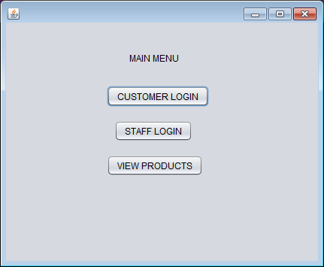
Customer Login
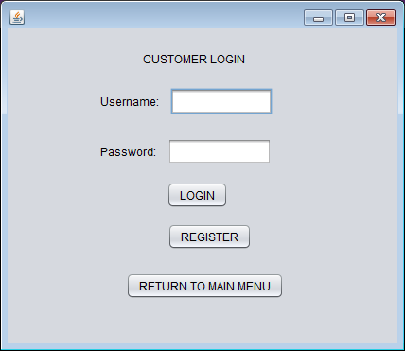

Staff Login
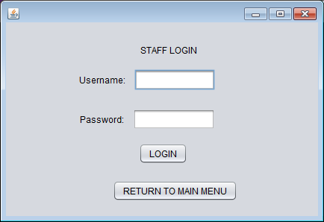

Connect ‘Customer Login’ (button on Main Menu) to your Customer Login JFrame.
Connect ‘Staff Login’ (button on Main Menu) to your Staff Login JFrame.
Note: At this time the ‘View Products’ button (on Main Menu) should not do anything.
Also at this time the ‘Register’ button (on Customer Login) should not do anything.

When customer logs in correctly they should be taken to a new form:
Customer Home
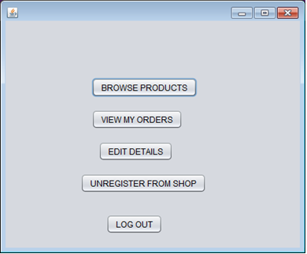
Note: At this time only the ‘Log Out’ button should be active- returning the user back to either the Main Menu or Customer Login form (your preference)

When staff logs in correctly they should be taken to a new form:
Staff Home
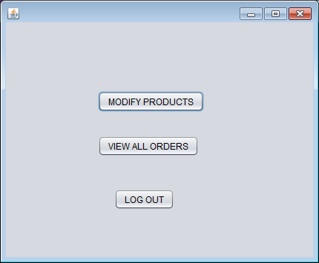
Note: At this time only the ‘Log Out’ button should be active- returning the user back to either the Main Menu or Staff Login form (your preference)

- Create new methods inside Customer and Staff class- both called displayGreeting.
DisplayGreeting for a Customer should return:
"Welcome [name]
Enjoy Shopping!"

DisplayGreeting for a Staff member should return:
"Welcome [name]
You are logged in as Staff"
Ensure you can now pass Customers and Staff members from the login page to their home page and you can now get the their greeting working:

Customer Home
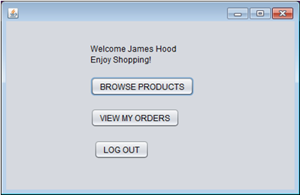
Staff Home
